Using an Applet to Demonstrate the Sampling Distribution of an F-statistic
True Treatment Values
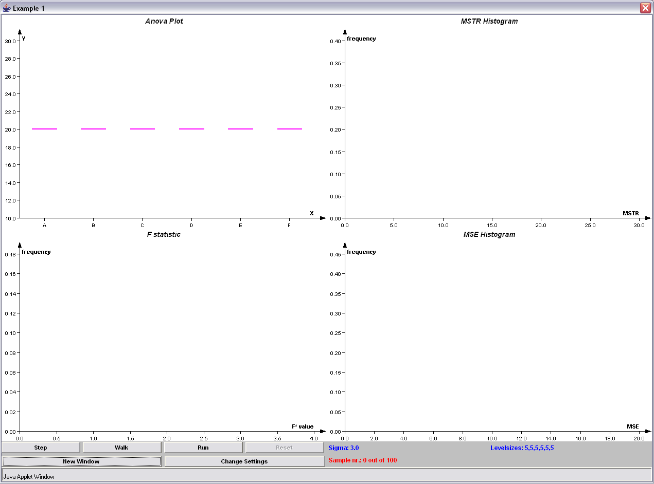
Change Settings

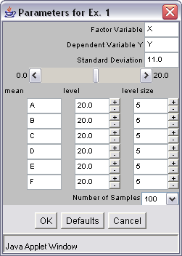
Click the “Change Settings” button, this allows you to change:
- the name of the factor variable
- the name of the dependent variable
- the pooled standard deviation
- the names of each of the treatments
- the true treatment level for each treatment
- the number of samples from each of the treatments
- the number of replications that are carried out by the applet.

Once you’ve made the desired changes, click “OK”. If wish you restore the settings to their defaults, click the “Defaults” button.

Next, by clicking on the “Step” button, this allows you to view samples and sample mean treatment level from each treatment population created one at a time and remains the focus of the applet until the “Step” button is clicked again and new sample points along with their mean are added to the plot. This helps illustrate how the F-statistic is created for each sample, however it does take a long time to go through all of your samples. The “Walk” button, when clicked, will show the sample points and sample mean treatment level, just like the “Step” button, but the applet will quickly progress through all the samples, as defined by the user under the “Change Settings” option.

Finally, the “Run” button moves through the sample points and sample mean treatment level process very rapidly. This option works best when there is a large level size and having a great number of replications.

As the sample mean treatment levels are created, the applet keeps track of the mean squared treatment and mean squared error for each instance of the ANOVA process on the right hand portion of the screen by way of histograms. After sample mean treatment levels are produced, the distribution of the mean squared treatment and mean squared error take shape and the theoretical distributions are graphed along with the simulated distribution. In addition, the applet takes the mean squared treatment and mean squared error values to create F-statistics which are then plotted on another graph along with the theoretical distribution.

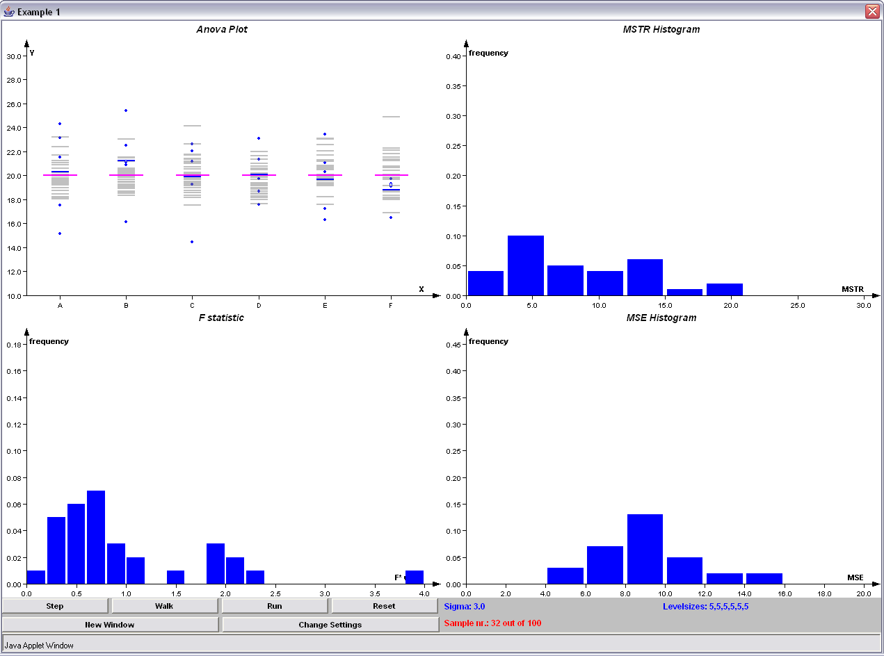
In Progress Applet

Clicking the “New Window” button will create new instances of the applet on the screen.

To restart the applet, click the “Reset” button.

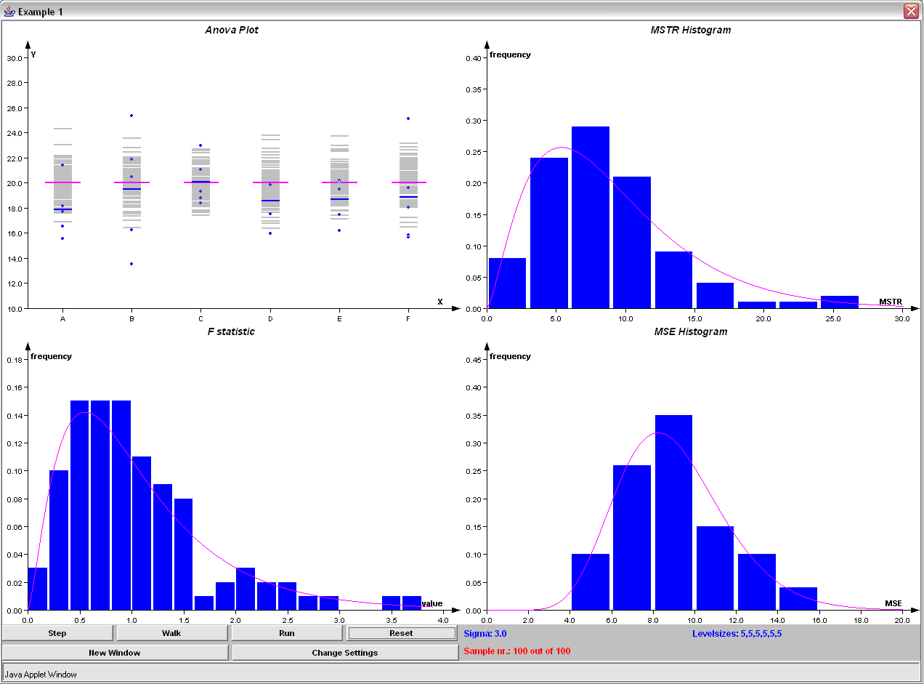
Completed Applet

